**Oracle Non-ASM to ASM Migration**

**==========================================**

**STEPS**

**---------**

* **Configure Disk for ASM**
* **Install Oracle 19c Grid**
* **Setup ASM Disk groups**

===============================================================================================

STEPS -1: Configure Disk for ASM

---------------------------------------------

ROOT USER

--^^^^^^^^^^--

**>> First of all, we need to install ASM packages as root user**

yum -y install oracleasm*

yum -y install kmod-oracleasm

**>> Add OS groups**

groupadd -g 54327 asmdba

groupadd -g 54328 asmoper

groupadd -g 54329 asmadmin

**>> Add asmdba as secondary group to Oracle user**

usermod -a -G asmdba oracle

**>> Create Grid User**

useradd -m -u 54331 -g oinstall -G dba,asmdba,asmoper,asmadmin,racdba grid

**>> Change the password for Grid user**

passwd grid

**>> Configure the Oracle ASM**

oracleasm configure -i

output

~~~~~

Default user to own the driver interface []: grid

Default group to own the driver interface []: dba

Start Oracle ASM library driver on boot(y/n) [n]: y

Scan for Oracle ASM disks on boot (y/n): y

Writing Oracle ASM library driver configuration: done

**>> Now we need to initiate Oracle ASM**

oracleasm init

output

~~~~~~

Creating/dev/oracleasm

mount point:/dev/oracleasm

Loading module "oracleasm": oracleasm

Configure "Oracleasm" to use device physical block size

Mounting ASMlib driver filesystem: /dev/oracleasm

**>> Add 30 GB HDD to virtual machine which will be used to create 3 partitions of 10 GB each for ASM disks**

**Open Virtual Machine**

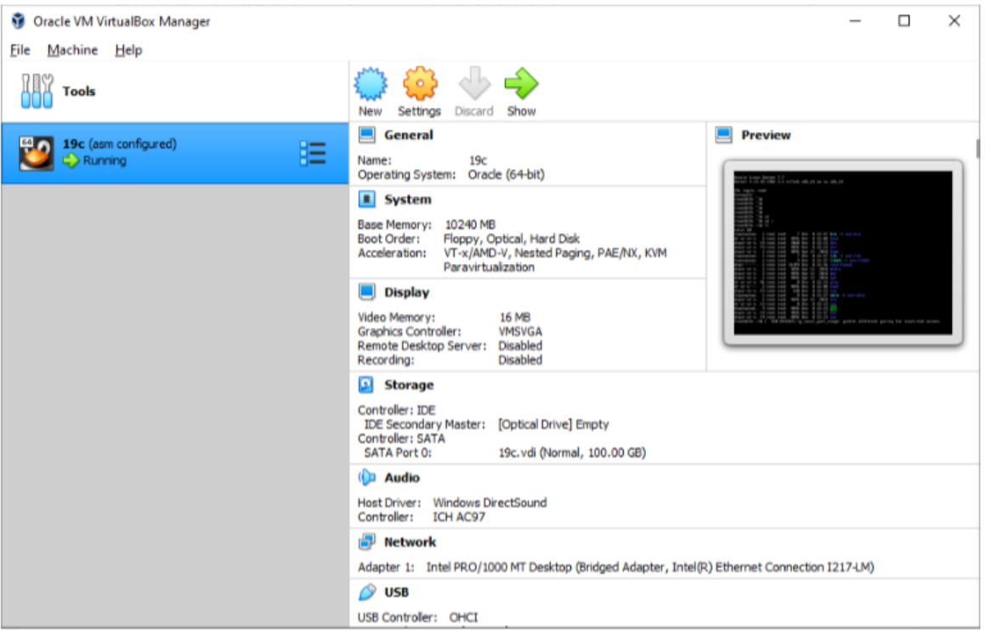

Settings >>Storage

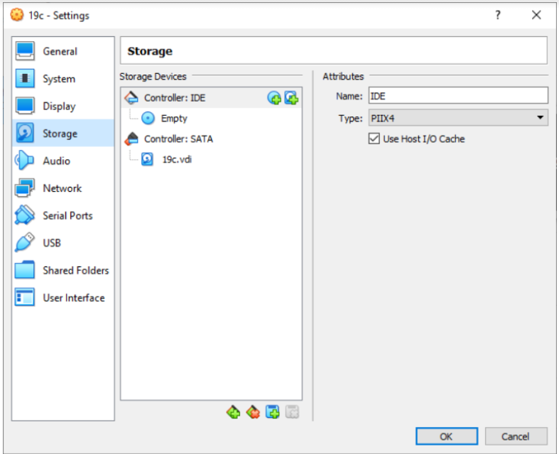

Controller SATA >> Create New Disk

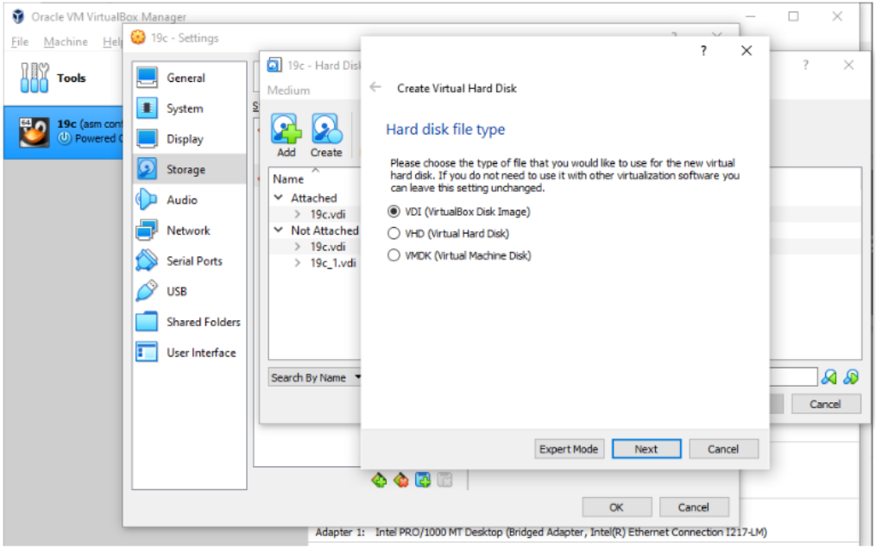

Click on Next

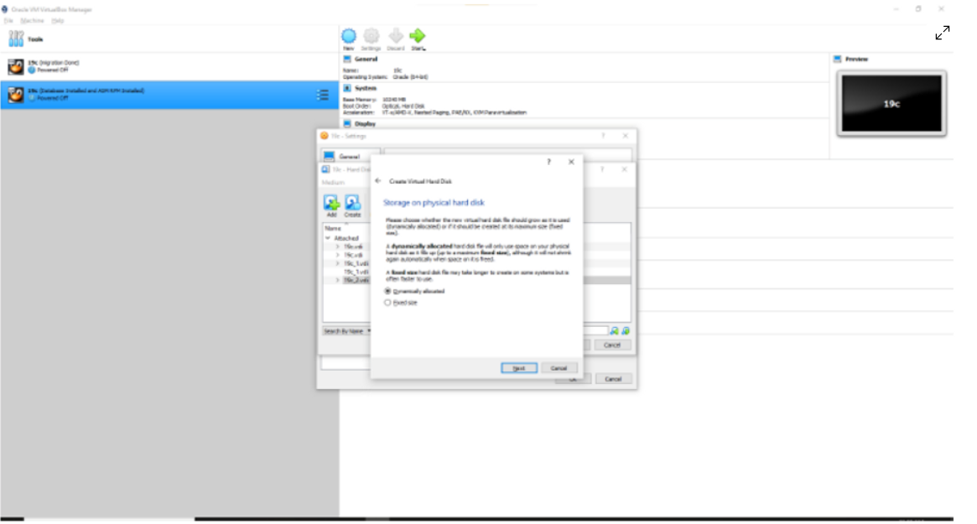

Give Size as 30GB >> Create

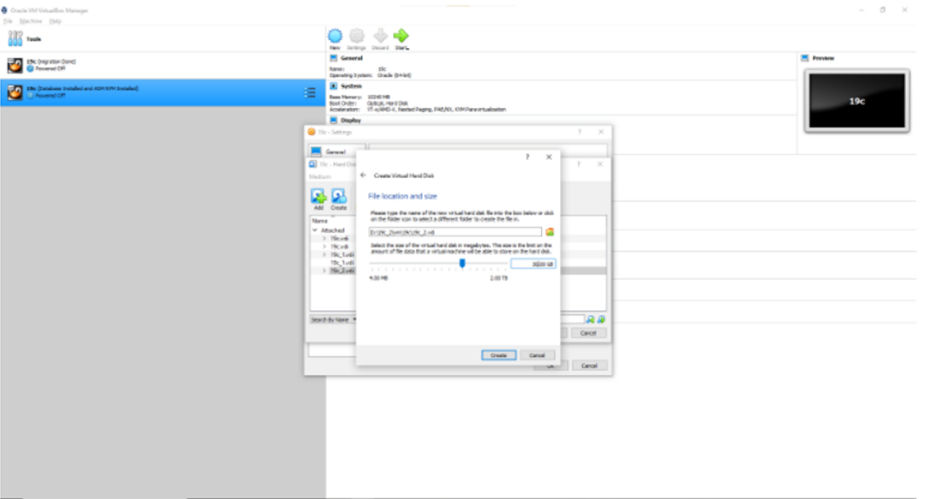

**>> once adding HDD is Done. Start virtual machine, login as root user and format the disk. You can see that the newly added disk is /dev/sdb**

fdisk -l

OUTPUT

~~~~~~~

Disk /dev/sdb: 37.6 GB, 37580963840 bytes, 73400320 sectors

Units = sectors of 1 * 512 = 512 bytes

Sector size (logical/physical): 512 bytes / 512 bytes

I/O size (minimum/optimal): 512 bytes / 512 bytes

Disk /dev/mapper/ol-root: 31.5 GB, 31457280000 bytes, 61440000 sectors

Units = sectors of 1 * 512 = 512 bytes

Sector size (logical/physical): 512 bytes / 512 bytes

I/O size (minimum/optimal): 512 bytes / 512 bytes

Disk /dev/mapper/ol-swap00: 10.5 GB, 10485760000 bytes, 20480000 sectors

Units = sectors of 1 * 512 = 512 bytes

Sector size (logical/physical): 512 bytes / 512 bytes

I/O size (minimum/optimal): 512 bytes / 512 bytes

**>> Format /dev/sdb disk and create 3 partition**

fdisk /dev/sdb

**Note:**

**--------**

n --> Create 1st partition

p

1

<enter>

+10g

n --> Create 2nd partition

p

2

<enter>

+10g

n --> Create 3rd partitions

p

3

<enter>

<enter>

w --> save partitions

**>> Confirm if you are able to see all the portion’s**

[root@19c ~]# fdisk -l /dev/sdb

Output

~~~~~~

[root@localhost ~]# fdisk -l /dev/sdb

Disk /dev/sdb: 37.6 GB, 37580963840 bytes, 73400320 sectors

Units = sectors of 1 * 512 = 512 bytes

Sector size (logical/physical): 512 bytes / 512 bytes

I/O size (minimum/optimal): 512 bytes / 512 bytes

Disk label type: dos

Disk identifier: 0xfce3f380

Device Boot Start End Blocks Id System

/dev/sdb1 2048 20973567 10485760 83 Linux

/dev/sdb2 20973568 41945087 10485760 83 Linux

/dev/sdb3 41945088 62916607 10485760 83 Linux

**>> Create separate ASM Disk for each partition**

oracleasm createdisk CRS1 /dev/sdb1

oracleasm createdisk DATA1 /dev/sdb2

oracleasm createdisk FRA1 /dev/sdb3

**>> [root@localhost ~]# oracleasm listdisks**

CRS1

DATA1

FRA1

**>> We can also check through**

ls -lrt /dev/oracleasm/disks

[root@localhost ~]# ls -lrt /dev/oracleasm/disks

total 0

brw-rw----. 1 grid dba 8, 17 Mar 4 02:20 CRS1

brw-rw----. 1 grid dba 8, 19 Mar 4 02:20 FRA1

brw-rw----. 1 grid dba 8, 18 Mar 4 02:20 DATA1

**>> Now we are ready to move onto oracle 19c grid infrastructure standalone installation!**

STEP-2 : Install Oracle 19c Grid

==========================

**>> Let us install the grid software as it contains the ASM binaries. Create directories for Oracle Grid installation**

https://www.oracle.com/in/database/technologies/oracle19c-linux-downloads.html

mkdir -p /u01/app/grid

mkdir -p /u01/app/grid/product/19.3/grid_home

chown -R grid:oinstall /u01/app/grid

chmod -R 775 /u01

**>>>>GRID USER<<<<<**

**>> Edit Grid user Bash_Profile and put below contents**

su - grid

vi .bash_profile

# .bash_profile

# Get the aliases and functions

if [ -f ~/.bashrc ]; then

. ~/.bashrc

fi

# User specific environment and startup programs

ORACLE_SID=+ASM; export ORACLE_SID

ORACLE_BASE=/u01/app/grid; export ORACLE_BASE

ORACLE_HOME=/u01/app/grid/product/19.3/grid_home; export ORACLE_HOME

ORACLE_TERM=xterm; export ORACLE_TERM

JAVA_HOME=/usr/bin/java; export JAVA_HOME

TNS_ADMIN=$ORACLE_HOME/network/admin; export TNS_ADMIN

PATH=.:${JAVA_HOME}/bin:${PATH}:$HOME/bin:$ORACLE_HOME/bin

PATH=${PATH}:/usr/bin:/bin:/usr/local/bin

export PATH

umask 022

:wq!

**>> Execute the bash profile and check environment variables**

. .bash_profile (or) source ~/.bash_profile

[grid@localhost ~]$ env|grep ORA

ORACLE_SID=+ASM

ORACLE_BASE=/u01/app/grid

ORACLE_TERM=xterm

ORACLE_HOME=/u01/app/grid/product/19.3/grid_home

**>> add grid software to VM machine**

Connect as grid user and unzip the grid software

cd $ORACLE_HOME

unzip LINUX.X64_193000_grid_home.zip -d $ORACLE_HOME

**>> restart**

[grid@localhost media]$ init 0

systemctl reboot -i

Start the gridSetup.sh which will install grid software. Make sure xming is up and running on your windows machine

[grid@localhost ~]$ cd $ORACLE_HOME

[grid@localhost grid_home]$ ./gridSetup.sh

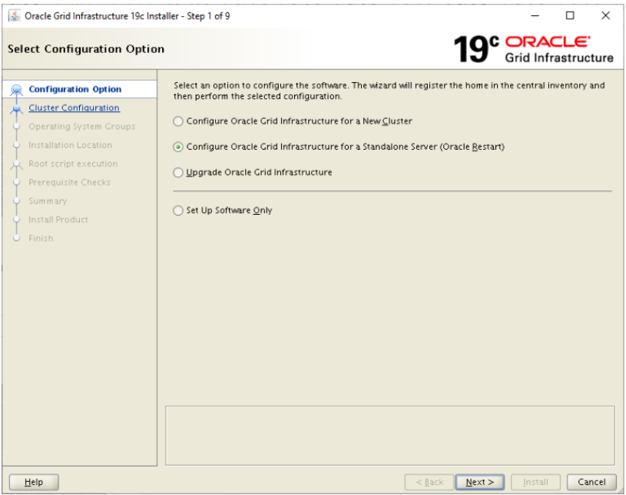

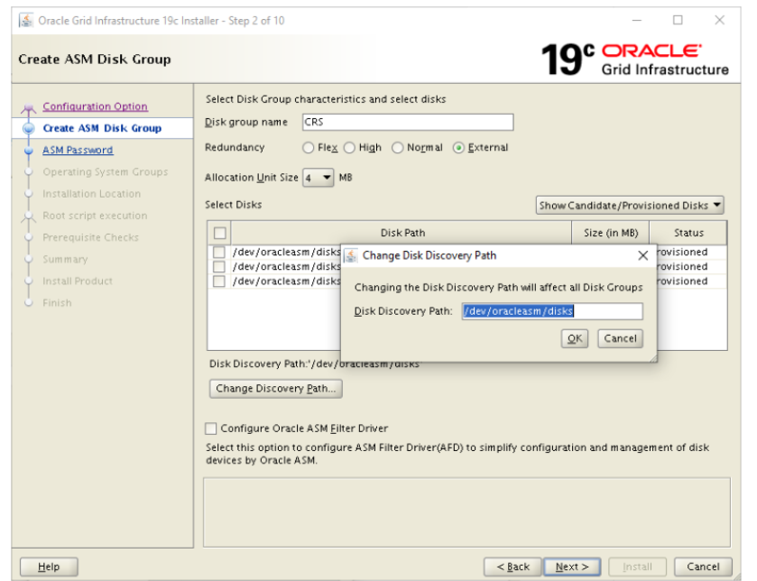

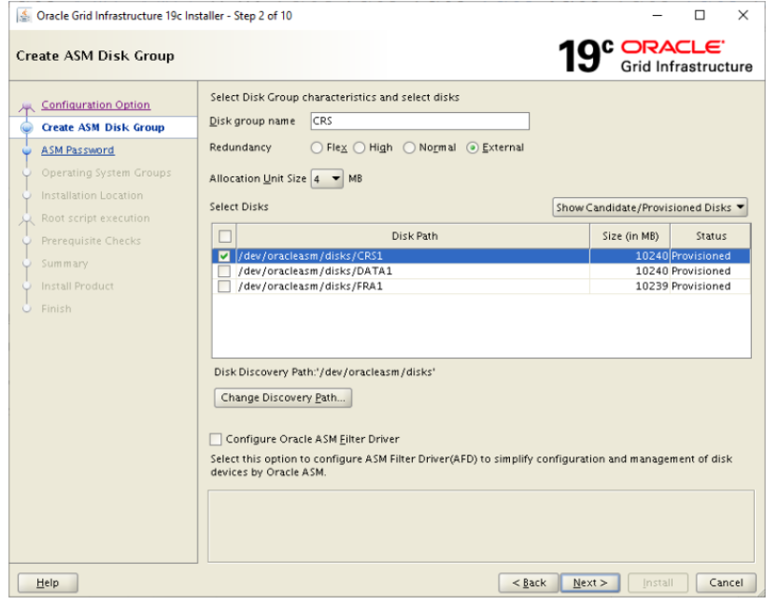

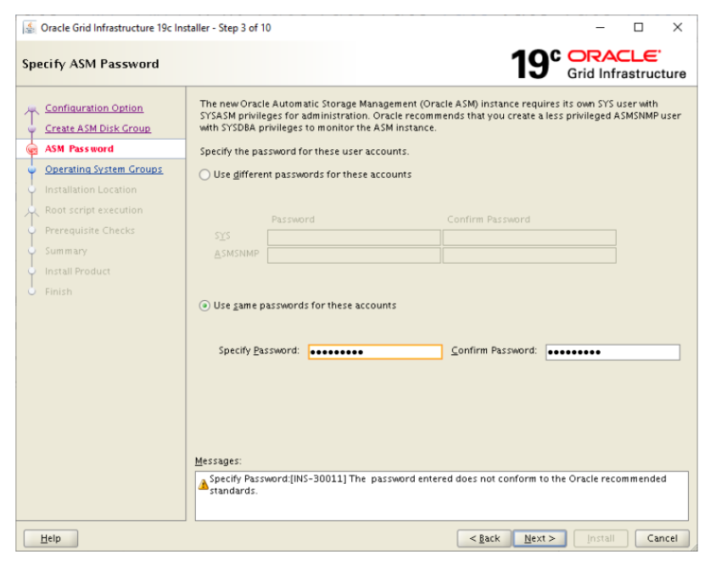

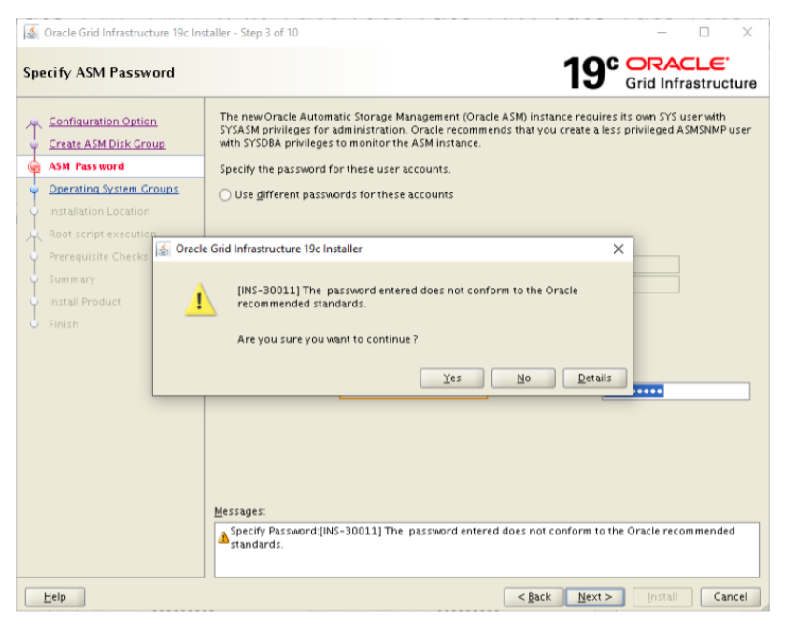

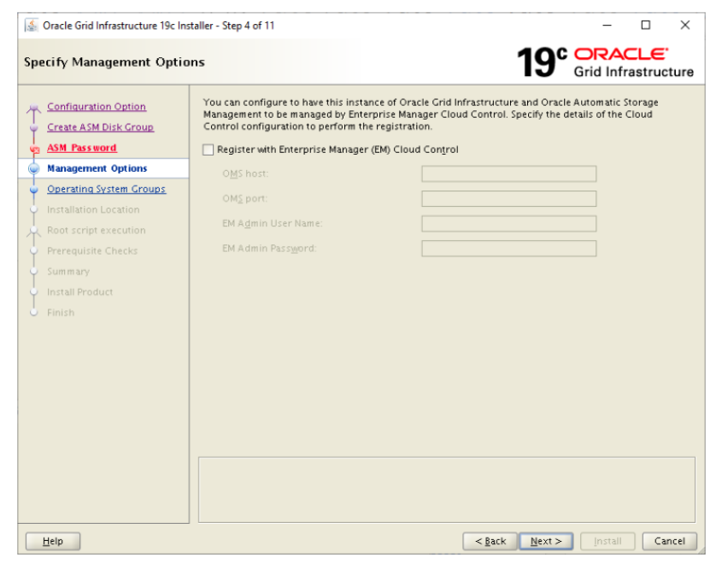

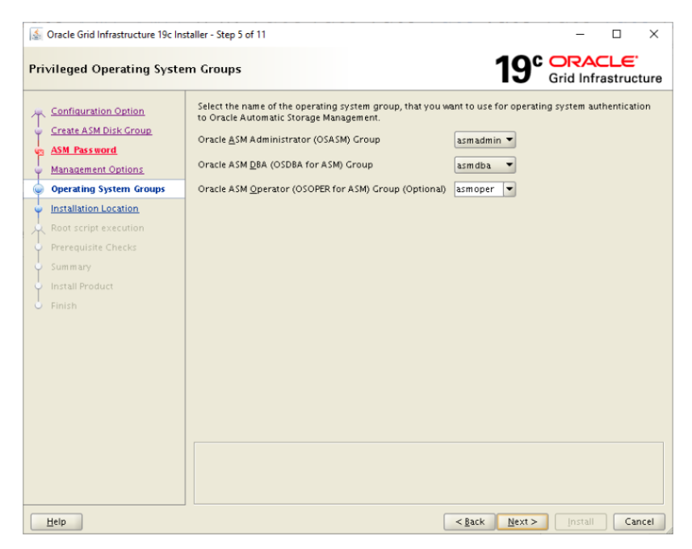

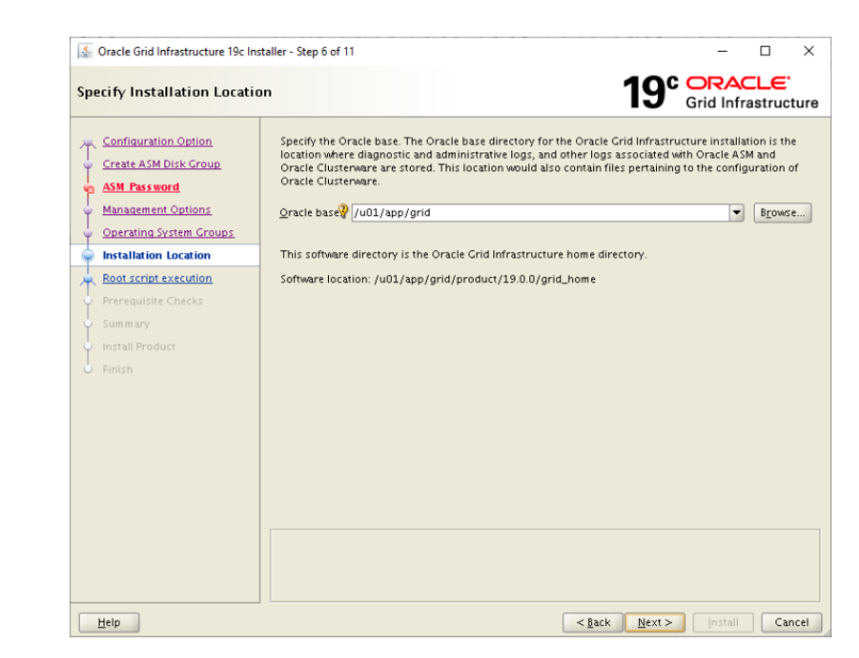

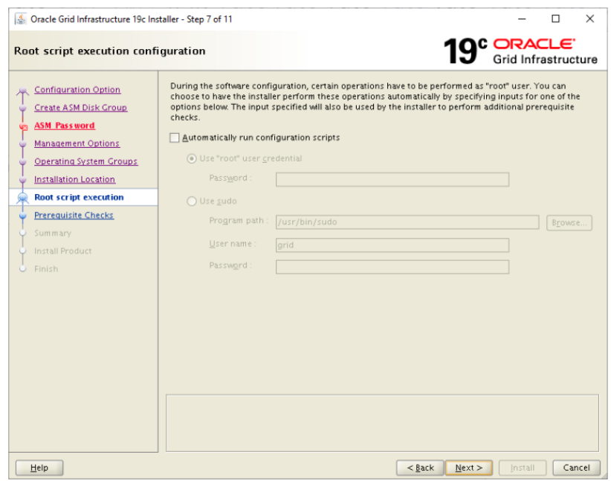

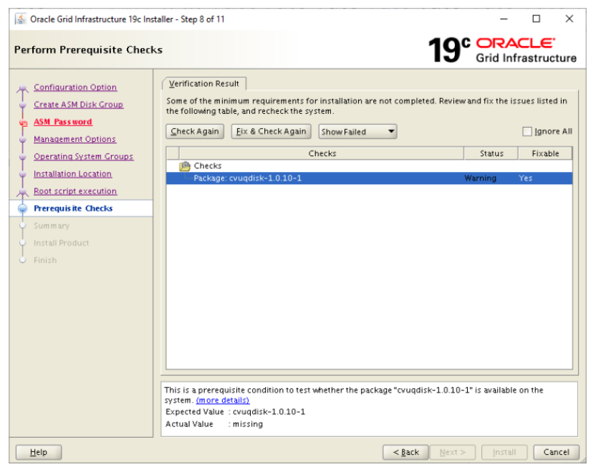

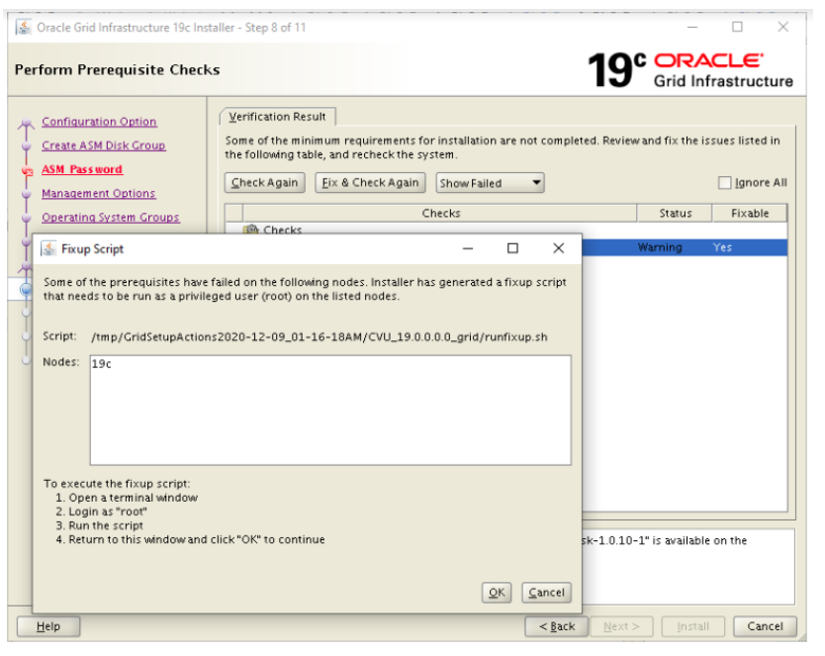

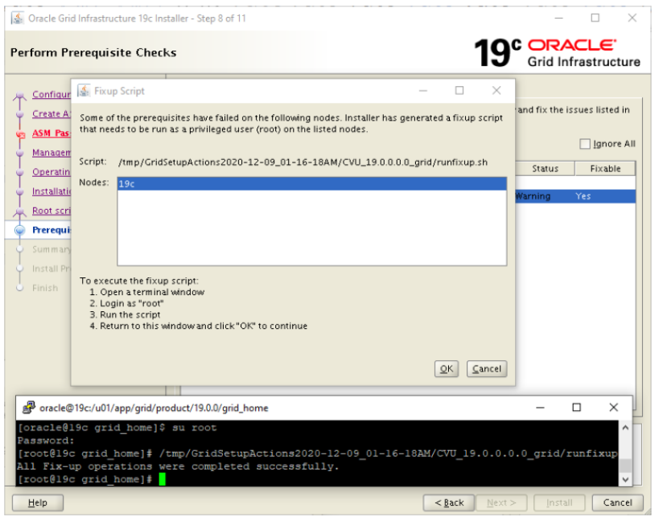

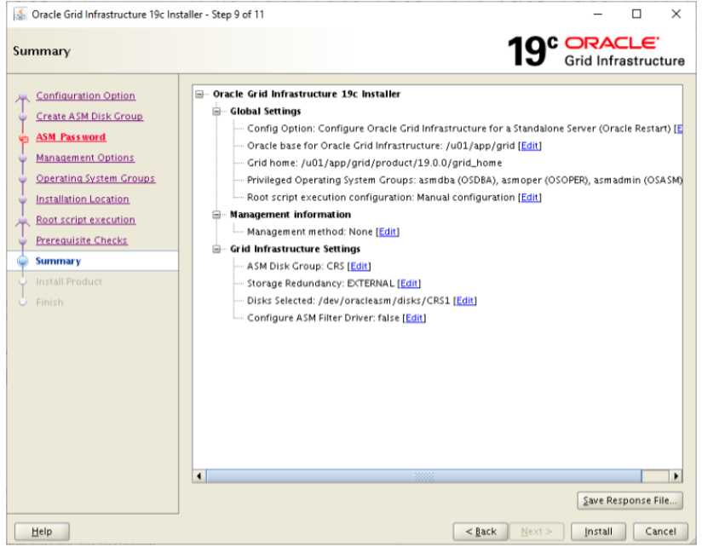

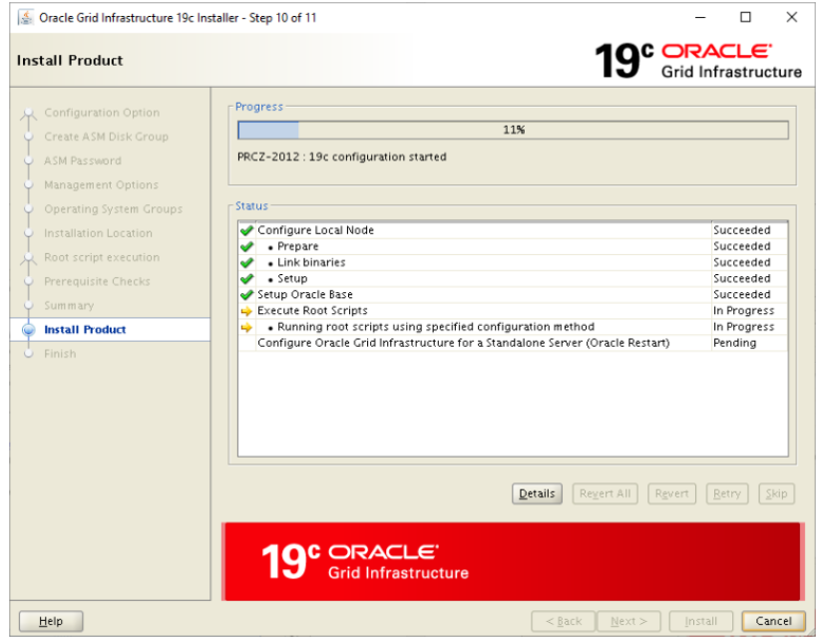

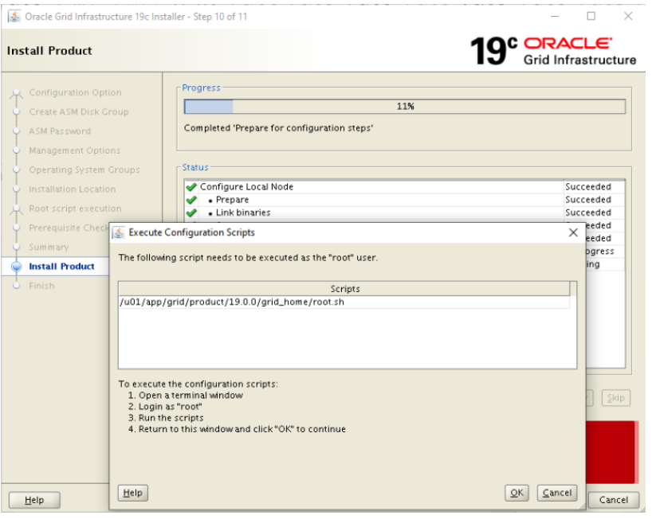

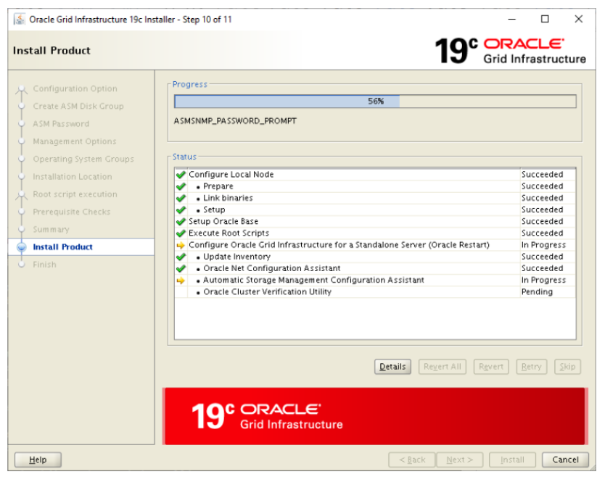

Oracle 19c Grid installation is completed.

STEP 3 : Setup ASM Diskgroups

-----------------------------------

**>> Start asmca to configure DATA and FRA diskgroups**

[grid@localhost grid_home]$ asmca

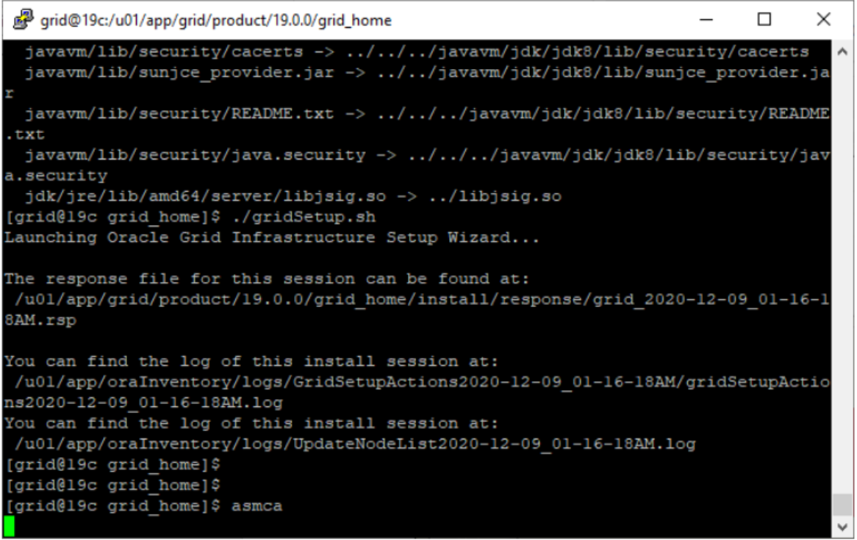

Click on create

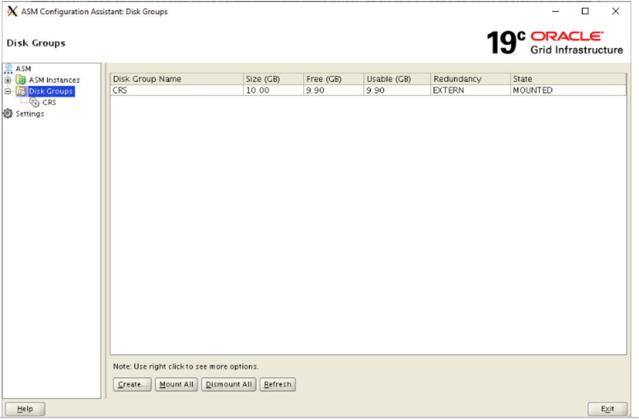

Disk Group Name: **DATA** >> Redundancy: **External** >> Select **DATA1 disk** >> Click on **OK**

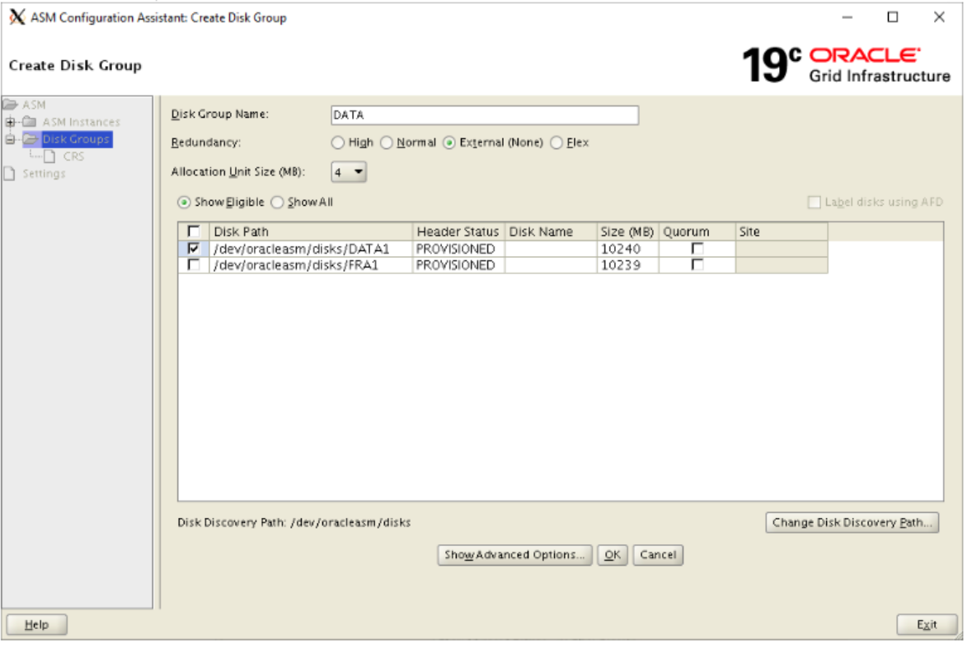

Let's create FRA diskgroup. Click on create. Disk Group Name: **FRA** >> Redundancy: **External** >> Select **FRA1 disk** >> Click on **OK**

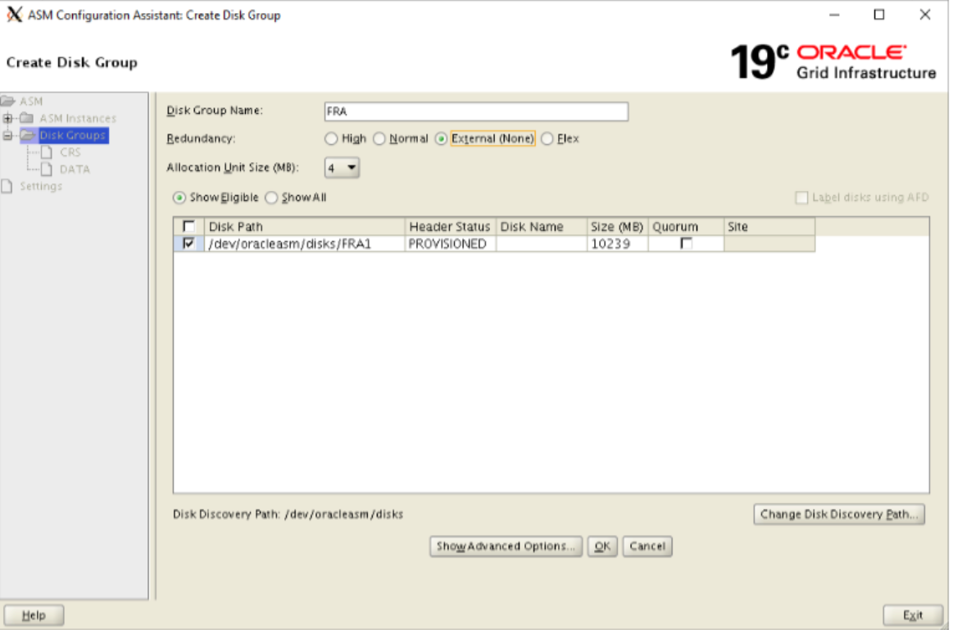

Exit from asmca.

SOURCE: https://support.dbagenesis.com/post/oracle-non-asm-to-asm-migration